WORKSHOP 9TH grade

1. Read the review below that Ashton made about his trip to South Africa.

“Southern Africa offers tourists many things to see. Game reserves offer a sight of Africa's rarest creatures. Deserts and breathtaking waterfalls are among the great landscapes that Southern Africa has to offer. If you are in search of city life, then visit Johannesburg or cosmopolitan Cape Town. The best time to visit southern Africa is during the cooler drier months, from May to October”.

1. Have you ever traveled to another city or country? How was your experience? Share below

__________________________________________________________________________________________________________________________________________________________________________________________________________________________________________________________________________________________________________________________________________________________________________________________________________________________________________________________________________________________________________________________________________________________

1. Are you planning to travel soon? Where? If you’re not, where would you like to go? Why?

__________________________________________________________________________________________________________________________________________________________________________________

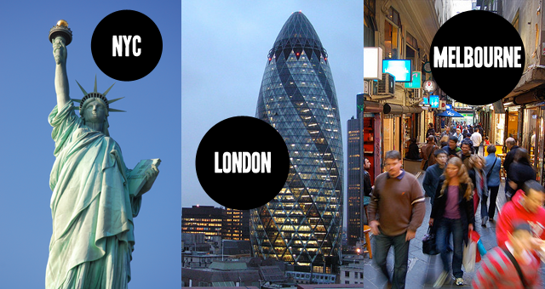

1. What do you see in this picture? Describe using adjectives.

______________________________________________________________________________________________________________________________________________________________________________________________________________________________________________

1. Do you know which places are these? Would you like to visit one of these iconic monuments?

______________________________________________________________________________________________________________________________________________________________________________________________________________________________________________

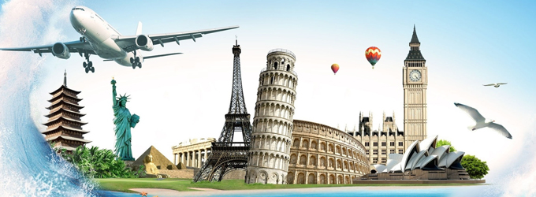

1. Put the verbs into the correct form (will, going to, simple present or present progressive).

* Philip  15 next Wednesday. *(to be)*
* They  a new computer. *(to get)*
* I think my mother  this CD. *(to like)*
* Paul's sister  a baby. *(to have)*
* They  at about 4 in the afternoon. *(to arrive)*
* Just a moment. I  you with the bags. *(to help)*
* In 2020 people  more hybrid cars. *(to buy)*
* Marvin  a party next week. *(to throw)*
* We  to Venice in June. *(to fly)*
* Look at the clouds! It  soon. *(to rain).*

GOOD LUCK. JOHN METRIO.